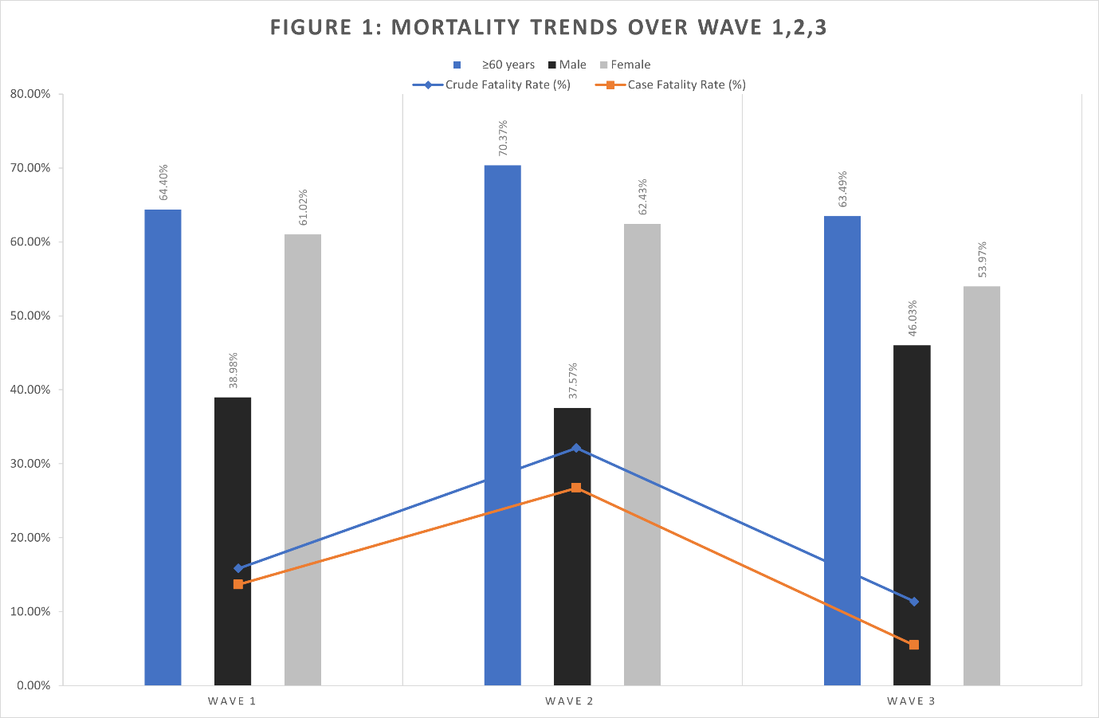
SAMJ 1054 appendix

Fig. 1. Bar graph depicting mortality rates in participants >60 years, as well as in males and females, during the first three waves of infection. Line graph showing the crude and case fatality rates during the first three waves.

